**Participation certificate – Shell Eco-marathon Europe 2014**

To whom it may concern,

Hereby I confirm that the TEAM NAME team, number TEAM NUMBER from UNIVERISTY NAME, COUNTRY represented by TEAM MANAGER has been selected to participate in the Shell-Eco marathon Europe organized by Shell. The competition will take place from the 15th to 18th of May 2014 at the Ahoy in Rotterdam, The Netherlands. The team will participate in the FUEL TYPE category with their VEHICLE NAME vehicle. Shell provides teams with accommodation in a campsite close to the racing circuit.

Since 29 years the Shell Eco-marathon Europe has been an active contribution to education and an integral element of Shell’s commitment to smarter development and mobility. The core element of Shell Eco-marathon is students from educational institutions from the whole world that are competing to design build and drive a vehicle using the less amount of fuel possible. It is an educational platform that encourages innovation, reinforces conservation and fosters the development of leading technology for greater energy efficiency.

This year more than 200 teams from 24 countries are selected to compete in Shell Eco-marathon Europe. Shell would be most grateful if you could assist all team members with the entry visa to be able to travel to the Netherlands in May 2014.

**All team members coming to event are:**

Name: Date of birth:

Asst.Prof. Namık Cıblak 01.07.1963

Cem Tutçu 15.08.1988

Anıl Özdemirli 19.04.1988

Şant Turaç 04.08.1991

Öznur Yılmaz 07.10.1991

Uğur Çaçan Yıldırım 19.08.1990

Deniz Sönmez 01.10.1991

Barış Yücebilgen 01.09.1993

Pınar Avcı 08.10.1993

Öznur Cebiroğlu 19.06.1993

Alican Emre Köksal 27.05.1991

Ramazan Gökay 20.04.1991

Mert Turhan 23.06.1987

Aslı Adıgüzel 24.06.1991

**The official address to Ahoy Rotterdam is:**

Ahoy Rotterdam

Ahoy-weg 10

3084 BA Rotterdam

The Netherlands

**Contact details to the event manager:**

Debby van der Voort  
CX Production Advisor - Production Centre of Excellence   
Exhibitions & Events  
Shell International B.V.  
Carel van Bylandtlaan 16, 2596 HR The Hague  
Tel:         +31(0)703775010  
Mobile: +31(0)621150032  
Internet: [www.shell.com](http://www.shell.com/)

Please do not hesitate to contact me if you require any further information or assistance.

Sincerely,



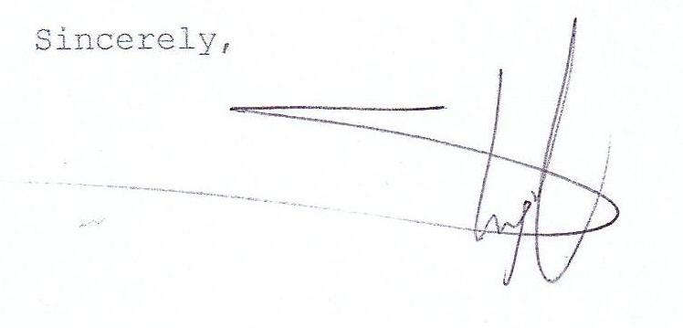

Sarah Engel

Sarah Engel

Shell Eco-marathon Europe 2014 – Participants Relations

Email: [shell-eco.marathon@shell.com](mailto:shell-eco.marathon@shell.com)

Internet : www.shell.com/ecomarathon